# Department of Computing

**CS-344: Web Engineering**

**Class: BSCS-6AB**

# Lab 10: AngularJS Basics

**Date: April 19, 2018**

**Time: 1000-1300 (BSCS-6B), 1400-1700 (BSCS-6A)**

# Instructor: Dr. Qaiser Riaz

# 

# Lab 10: AngularJS Basics

### Introduction:

AngularJS is an MVC (or MVV) based JavaScript framework which is widely used to develop single page web applications. Students have learned basic concepts of AngularJS in the lectures. This lab will help them to further understand these concepts by developing example applications.

### Lab Objectives:

The objective of this lab is helping students to familiarize themselves with basic usage of AngularJS in developing single page web applications. Students will develop small applications using AngularJS according to the given scenarios. The knowledge students have gained in the lectures will help them to control dynamic behavior of web pages.

### Tools:

Notepad, DreamWeaver, browser.

### Helping Material:

Lecture slides.

W3Schools: <https://www.w3schools.com/angular/default.asp>

AngularJS Cheatsheet: <https://dncmagazine.blob.core.windows.net/downloads/AngularCheatSheet-DNCMagazine.pdf>

### Lab Task

### Task 1

In the supporting material compressed file (see ‘lab-10-supporting-material.zip’), a skeleton html file is given which include basic skeleton (‘lab-task-1-skeleton.html’) for this task. The skeleton consists of a list of names *($scope.names*) which are shown in an unordered list using *ng-repeat* directive. The skeleton also contains a form with a text field and an *Add* button. Your task is following:

1. When a user clicks on the *Add* button after entering a name in the text field, the input must be matched with the existing names in the *($scope.names*) list. If no match is found, then the entered name should be added in the list and the unordered list should be updated automatically.
2. If entered name already exist in the list, the user must be informed with an alert message as shown below:

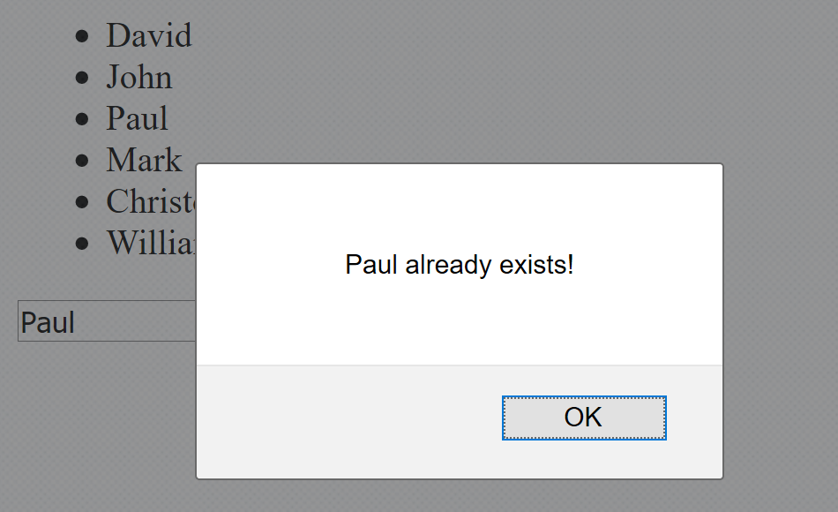

Hints:

1. You have to loop through *$scope.names* to match the input with the list. Use a javascript *for* loop and control its total iterations using $scope.names.length.
2. Use javascript if-else statements to match each item in the list with the enteredName. Javascript’s ‘===’ can be used to compare strings
3. Use $scope.names.push($scope.names.enteredName) to push newly entered name in the list.

### Task 2

Extend the example give in ‘lab-task-2-skeleton.html’ to display the data given in ‘population.json’ file in an HTML table as shown in the following screenshot.

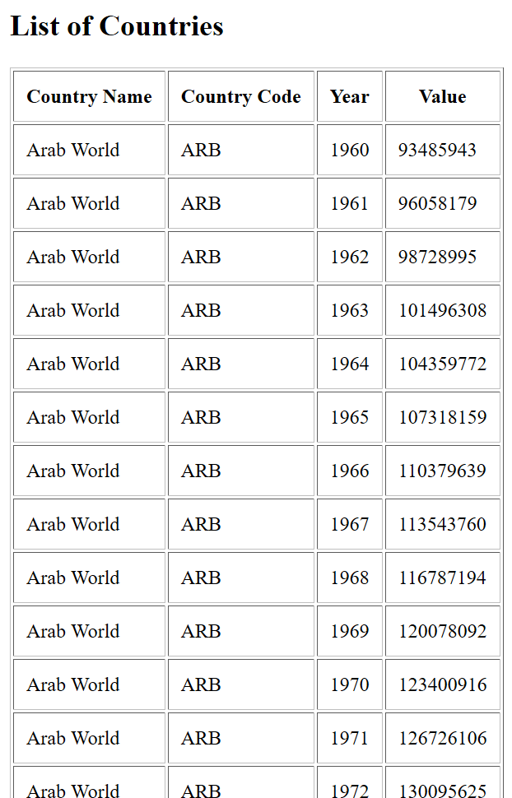

Hints:

1. You can copy the data from the json file and paste it in the html file.
2. Use *ng-init* to initialize data and *ng-repeat* to loop through the data while displaying it in table rows.

### Deliverables

Convert your solutions for task 1 and 2 into a zip folder and upload to LMS before the submission time. The lab grading policy is as follows: The lab is graded between 0 to 10 marks. For some of the labs, students have to present their solutions in a viva session. In case of any problems with submissions on LMS, you should contact your lab engineers: Mr. Ahsan Gul - [ahsan.gul@seecs.edu.pk](mailto:ahsan.gul@seecs.edu.pk). or Ms. Ayesha Asif [ayesha.asif@seecs.edu.pk](mailto:ayesha.asif@seecs.edu.pk).